**The Bach Biodynamic Planting and Research Calendar.**

**2013**

Based on Indications Given by Rudolf Steiner

C:\Documents and Settings\jb15215\Local Settings\Temporary Internet Files\Content.IE5\0M43NS56\MC900198445[1].wmf

**Introduction**

Welcome to the inagural edition of the Bach Biodynamic Planting and Research Calendar. Most of us have had the experience of planting a crop one year and having a good harvest, and then, in a subsequent year, planting the same crop, using the same seed, under generally the same weather conditions, and having a poor harvest. Could the answer to this dillema be the timing of sowing the crop? This calendar will attempt to help find answers to this and other questions. The purpose of this calendar is to provide an ongoing research platform for finding and refining best practice in biodynamic agriculture, using indications given by Rudolf Steiner as a foundation. This calendar will carry research themes for each year and provide a practical framework for collecting data which can then be collated and assessed. This calendar is intended to be a research-driven calendar, with previous findings providing the direction for future research. The pages of this calendar not only provide the most favourable times for planting crops, but also a research option, where you, the researcher, if you so chose to participate, carry out small planting trials (12 seeds per trial this year) on dates that correspond to the comparisons being made for the theme of the year. At the end of the trial dates, this information is then sent to me, where I will tabulate the information, and make conclusions on findings. This information will also be written in an article form, and sent to the Biodynamic Journal for publication, to help further our understanding of planting rhythms. Findings will also be published in the following year’s calendar, and send by e-mail upon request. Best of all, doing this kind of systematic planting research will make you a better gardener by giving you with a sounder understanding of the role various cosmic bodies play in the growth of plants!

**2013 Theme of the Year**

The theme of the 2013 calendar year is to compare the effect of waxing and waning moon phases given by Rudolf Steiner, and trigons, given by Maria Thun. Rudolf Steiner gave a series of lectures in Koberwitz in 1924, which have come to be known as “*The Agriculture Course,”* and which form the foundation upon which the Biodynamic movement stands[1]. In the first lecture of of the Agricultural Course, Steiner spoke of how the waxing moon provides the best time to plant crops, as it is the time when the strongest forces of the moon radiate to the earth. He spoke as follows: “…with the forces that come from the Moon on days of the full Moon, something colossal is taking place on the Earth. These forces spring up and shoot into all the growth of plants, but they are unable to do so unless rainy days have gone before...the Earthly forces of growth are feeble and unable to sustain plants. Through the forces of the Moon, the forces of growth are strengthened to the point where they can then become reproductive forces (p.109)” [i.e. develop to the point of ultimately producing seed] [2]. These indications were taken up by Lili Kolisko, and have been published in her incredible book “*Agriculture of Tomorrow”*[3]. Kolisko undertook hundreds of planting trials, with almost all of the annual plants that would be grown by a gardener or farmer. She compared the growth of plants when planted two days before a full moon (when the forces of growth from the moon are the strongest) and two days before a new moon (when growth forces are the weakest). In every case she found the forces of the waxing moon gave the best growth, harvest, and quality. Regarding the growth of tomatoes, for example, Kolisko found the following:

In the year 1934 the full moon tomatoes yielded on increase by more than 100%. The weight of a single tomato sown two days before full moon was between 280-350 grams (9-12 oz.); of a single tomato sown two days before a new moon 120-180 grams (4-6 oz.). Considering the experiments of many years, we can recommend with good conscience that tomatoes should be sown two days before full moon.

As a general rule, we observe that the seeds sown two days before full moon push through the soil very quickly in a few days time. Seeds sown two days before new moon take a much longer time. In most cases we find that those seeds **wait in the soil for the next waxing moon** [emphasis by Kolisko]. But even if they wait until the next full moon to germinate, they do not benefit from the full moon so much, as the seeds which have been sown right from the beginning at the right time.[4]

Rudolf Stiener’s indications and the subsequent work carried out by Lili Kolisko regarding waxing and waning phases have largely been forgotten by biodynamic practitioners, who now instead rely on the indications and work of Maria Thun. Maria Thun began her research in the 1905s, and found variations in the quality and form of radishes in both root and leaf. Over the years, Thun developed a theory that plants grew and developed differently when the moon was in one of the twelve zodiacal constealltions. She grouped the twelve signs of the zodiac into four trigons (a trine is a 120**°** angle,formed, in this case, between the different constellations). She then divided the constellations into four group as follows:

Root crops (Earth element): Taurus, Capricorn, Virgo

Leaf crops (Water element): Cancer, Pisces, Scorpio

Flower crops (Light element): Gemini, Aquarius, Libra

Fruit/Seed crops (Fire/warmth element): Aries, Leo, Sagitarius

The moon travels through each of the individual constellations over a period of 2-4 days, depending on the size of the constellation. Each one of these planting times repeats, in the order of fruit, root, flower and leaf. To my knowledge, all of the published biodynamic planting calendars follow this method of planting. Unlike the systematic work carried out by Lili Kolisko, there has not been a defintivive and widely accepted body of work which supports and confirms Thun’s theory.

The goal of this year’s research is to compare the growth of seeds when sown 2-3 days before a full moon (waxing phase), to the same seeds sown 2-3 days before a new moon. The seeds sown before the new moon will be planted on the corresonding trigon day, while the seeds sown before the full moon will *not* be planted on the corresponding trigon day. In this way, the growth of plants sown under the influence of the full moon will be compared to the growth of plants grown under the corresponding trigon, but during a waning phase. These results will then be compared. For example, the first planting trial in January involves planting lettuce on January 9th, which is a leaf day and two days before a new moon (waning phase). The next planting date for this trial is on January 24th, a flower day, but two days before a full moon. The germination and growth of these plants will be measured after each of the planting sets has grown for 30 days. Part if this year’s research will be indoors, in a location that receives good light and has a steady temperature. The best location will, for most, be a windowsill with south oreinting light. In this way, the same conditions will exist for each set of seeds sown, with only a slight difference in light levels as the sun approaches solstice. Varying weather conditions (temperature and moisture levels) have made it difficult for past research to ascertain the effect of various constellational influences on the growth of plants with certainty. The goal of this indoor portion of the research is to eliminate confounding variables like temperature and moisture levels.

**Conducting the Reaseach**

This year’s research will be divided into two sets. The first set involves a total of 6 windowsill plantings over a three month period. Please use the window in your house or apartment that receives the most light (usually south facing). **It is essential that the seeds from both sets of a trial are placed in the same location (side by side), so that they are exposed to the same temperature and light conditions for compairison purposes.** One sowing trial of 12 seeds will take place during both the waning and waxing phase of January, February and March, for a total of six trials. The vegetables to be sown are: lettuce in January and radishes in February and March. The number of seeds that germinate in each trial will be recorded in the data sheets provided for each planting trial. After 30 days, each plant that has sprouted and developed will be carefully removed from its pot or tray, washed to remove all dirt from the root, and then measured (please use centimetres) and weighed (please weigh in grams). Record this data on the sheet provided. **All data must be collected on the dates indicated, in order for the data to be combined with other data provided by all of the participants in this study.**

The second set of trials will also include 6 plantings of 12 seeds each over a three month period, but instead of pulling plants out the ground after 30 days and measuing and weighing them, this second trial will allow the plants to develop to full maturity before they are harvested, mesaured or counted, and weighed. The seeds of this second trial will also be sown in containers indoors, where they will be allowed to grow for 30 days. After 30 days, they are to be planted outdoors, in your garden or farm. **It is essential that the seeds sown and the plants that are later planted out are done so in the same location, with the same soil, so as to receive the same light and climatactic conditions.** The plants of this second set of trials will be measured from the ground up after 30 days, and then planted out. For this second trial, seed trays with individual compartments, or small pots are recommended, so as to disturb the roots as little as possible during transplanting. The vegetables for the second trial are as follows: lettuce in April, bush beans in May, beets in June.

A household kitchen scale used for measuring food will work well for this research, provided it can measure weights as low as 10 grams, and as high as 500 grams ( about 1 pound). These types of scales are available for around $10.00 at most supermarkets. Lee Valley carries an excellent digital scale with a tare option for about $15.00.

**Important Points to Remember when Gathering Data**

* Always collect data on the dates indicated
* Wash dirt off of plants, and allow to dry for a half an hour, or dry with a paper towel before weighing or measuring
* Always weigh and measure plants on the same day they are harvested
* If using your own seed, please include information about the seed, or if the seed is your own that has been saved

The seeds that are being used in this trial, which I have purchased and have been provided at the meeting are from West Coast Seeds. It is not essential that these seeds be used for the study, but it is essential that the same vegetable is planted for each of the trials. The following vegetables must be planted on the following dates so that viable data can be collected:

* January 9th & 24th – Lettuce
* February 8th & 23rd – Radishes
* March 8th & 25rd – Radishes
* April 8th & 23rd – Lettuce
* May 6th & 22nd – Bush Beans
* June 6th & 21st – Beets

It is also not essential that all of the trials be conducted in the calendar. If it is not possible, for example, to conduct the January lettuce trial, the other trials can be conducted and the data used. The ideal is, of course, that all of the trials be completed. The more data that is collected, the more accurate will be the results of this study.

**Please send the completed data from trials 1, 2 and 3 to me via e-mail by April 30th, so that I can begin to process all of the data and write up the results. Please send the data from trials 4, 5, and 6 to me no later than August 30th. Ideally, send the data from each trial as soon as it is completed. My e-mail address is:** [**jbbach1@yahoo.ca**](mailto:jbbach1@yahoo.ca) **.**

**About Best Planting Times**

This calendar contains a range of dates (between 2-4 days each month) that are the best times for sowing seeds, as indicated by Rudolf Steiner. These days always fall somewhere between 6-2 days before a full Moon. The Moon is here considered to be the greatest force that influenes the growth of plants. In the first lecture of *The Agricultural Course* Steiner also indicated that the inner (Mercury and Venus) and the outer (Mars, Juptiter and Saturn) planets also influenced the growth of plants. Generally, the inner planets influence the growth of annual plants, while the outer planets influence the growth of longer lived plants, specifically, plants with bark or rind. He spoke specfically, for exmple, of how Oak trees were related to the forces of Mars, while, confierous trees were related to the forces of Saturn. Still in the first lecture, Steiner also spoke of the relationship of silica and limestone forces to the planets. The inner planets carry the forces of limestone into the earthly realm, while the silica forces are carried by the outer planets. Steiner speaks of these limestone forces as contributing ultimately to the formation of seeds. Thus the inner planets are connected to the development of seed crops. These would include, for example, pod plants (peas, beans, etc), corn, and the various grains. In short, these are the plants whose seeds we consume. The silica forces of outer planets work on the development of plants that Steiner described as being foodstuffs for animal and man. Plants in this group are not eaten for their seeds, but the food they produce. Examples include root crops (carrots, beets, potatoes, etc.), and the flesh of fruits and vegetables (apples, squash, melons, tomatoes, etc.). These plants are referred to as nutritive crops in this calendar.

The moon is the force that ulimatley magnifies and directs the forces of these planets to the earth. Steiner described this in leture six of the *Agricultural Course* as taking place when the Moon ‘reflects’ the forces of the planets to the earth. This takes place when the Moon is in opposition to a planet, and thus shines these forces onto the earth. A full Moon, is, for example, an opposition between the Sun and the Moon, with the Earth in the middle. Thus, the rays of the Sun are magnified and amplified onto the Earth during a full Moon, bringing about forces of growth in plants. This is also the case for the various planets. Therefore, during a waxing phase of the Moon, if there is also a corresponding innner or outer planet moving into opposition with the Moon, these forces will also be cast onto the Earth. Steiner spoke of two days before a full Moon as the time when the forces of growth carried by the Moon were strongest. It is assumed (Steiner did not directly state this), that two days before a planetary opposition is also when the forces of a planet are strongest. Thus, any outer lunar-planetary opposition that occurs during a waxing phase should be considered as an ideal time to plant nutritive crops, while any inner lunar-planetary opposition should be considered as an ideal time to plant annual seed crops. There are times during the 2013 year when both inner and outer planetary – lunar oppositions occur, and these times offer excellent planting opportunities for all annual crops. I have indicated June 20-21 to be the best planting time offered in the 2013 year. During this time, there is waxing Moon, and also both inner and outer planetary-lunar opposition. On the west coast of Canada, this is also a time when soil temperatures are ideal, and where there is still enough time to plant longer maturing crops, as September has generally been a warm month in this part of the world.

Lastly, Steiner also spoke of how (in the first lecture of the *Agricultural Course)*, in addition to the moon, the element of water is essential to mediating the limestone forces into the earthly realm, while the silica forces also need the warmth element in order to penetrate the earthly realm. This means that an element of judgement needs to be exercised by the user of this calendar. Planting seed crops during a dry period will be less productive than during a rainy time, and planting nutritive crops during a cold period will be less productive that during a warmer peroid. Watering in seeds will benefit dry planting times, but planting of nutrtive crops should only be done during warm periods. Beets, for example, will not form edible roots if planted in cold soil.

All times in this calendar are in Pacific Standard Time (PST)

The themes discussed here have only been touched upon, but a much more detailed and in depth discussion of the premesis for this calendar is provided in my essay ‘*Rudolf Steiner’s Indications Regarding Cosmic Influences Upon the Growth of Plants’.* I will e-mail it, upon request, free of charge to anyone interested.

Happy Planting and Warmest Regards,

John Bach

[jbbach1@yahoo.ca](mailto:jbbach1@yahoo.ca)

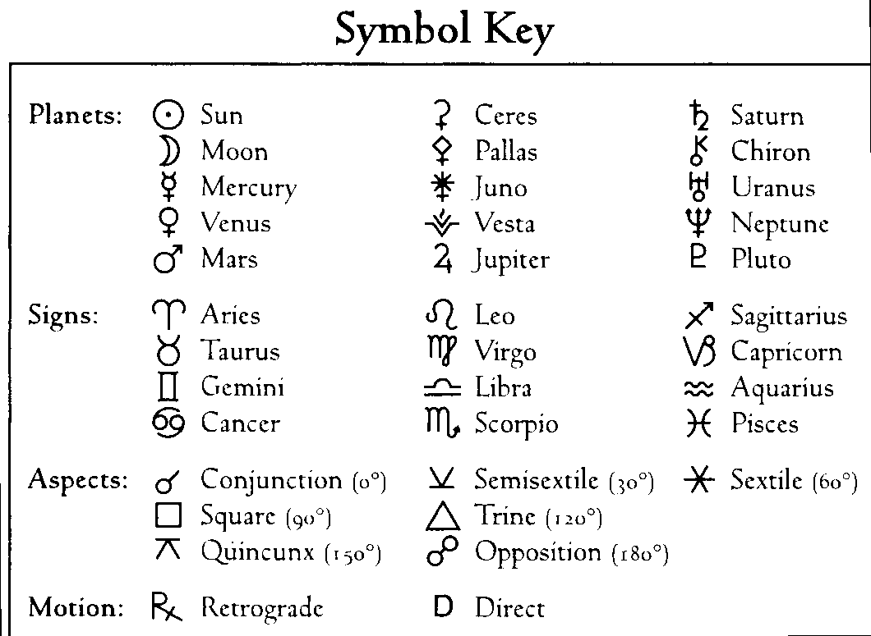

**Important Dates in this Calendar at a Glance**

January 9th- Plant lettuce trial 1a

January best planting days: 23rd & 24th

January 24th- Plant lettuce trial 1b

February 8th- Plant radishes trial 2a

February 8th- Measure and weigh lettuce 1a

February best planting days: 22nd & 23rd

February 23rd – Plant radishes for trial 2b

February 23rd- Weigh and measure lettuce from 1b

March 8th- Plant radishes trial 3a

March 10th- Measure and weigh radishes from 2a

March best planting days: 22nd-25th

March 25th- Plant radishes trial 3b

March 25th - Measure and weigh radishes from 2b

April 7th - Measure and weigh radishes from 3a

April 8th- Plant lettuce for trial 4a

April best planting days: 22nd & 23rd

April 23rd – Plant lettuce for trial 4b

April 24th- Measure and weigh radishes from 3b

May 6th- Plant bush beans trial 5a

May 8th- Measure and plant-out lettuce from 4a

May best planting days: 21st- 22nd

May 22nd – Plant bush beans trial 5b

May 23rd- Measure and plant-out lettuce from 4b

June 2nd – Measure and weigh lettuce from 4a

June 5th- Measure and plant-out bush beans from 5a

June 6th- Plant beets for trial 6a [after 10 am PST]

June 17th- Measure and weigh lettuce from 4b

June best planting days- 20th-21st (best of year)

June 21st- Plant beets trial 6b

June 21st Measure and plant-out bush beans from 5b

July 1st- Count and weigh bush beans pods from 5a

July 6th- Measure and plant-out beets from 6a

July 17th- Count and weigh bush bean pods from 5b

July best planting days: 18th-20th

July 21st- Measure and plant out beets from 6b

August 5th- Weigh beets from 6a

Best August planting days- 15th-18th

August 20th- Weigh beets from 6b

September best planting days: 14th-17th

October best planting days: 16th

November best planting days: 13th-15th

December best planting days: 13th-15th

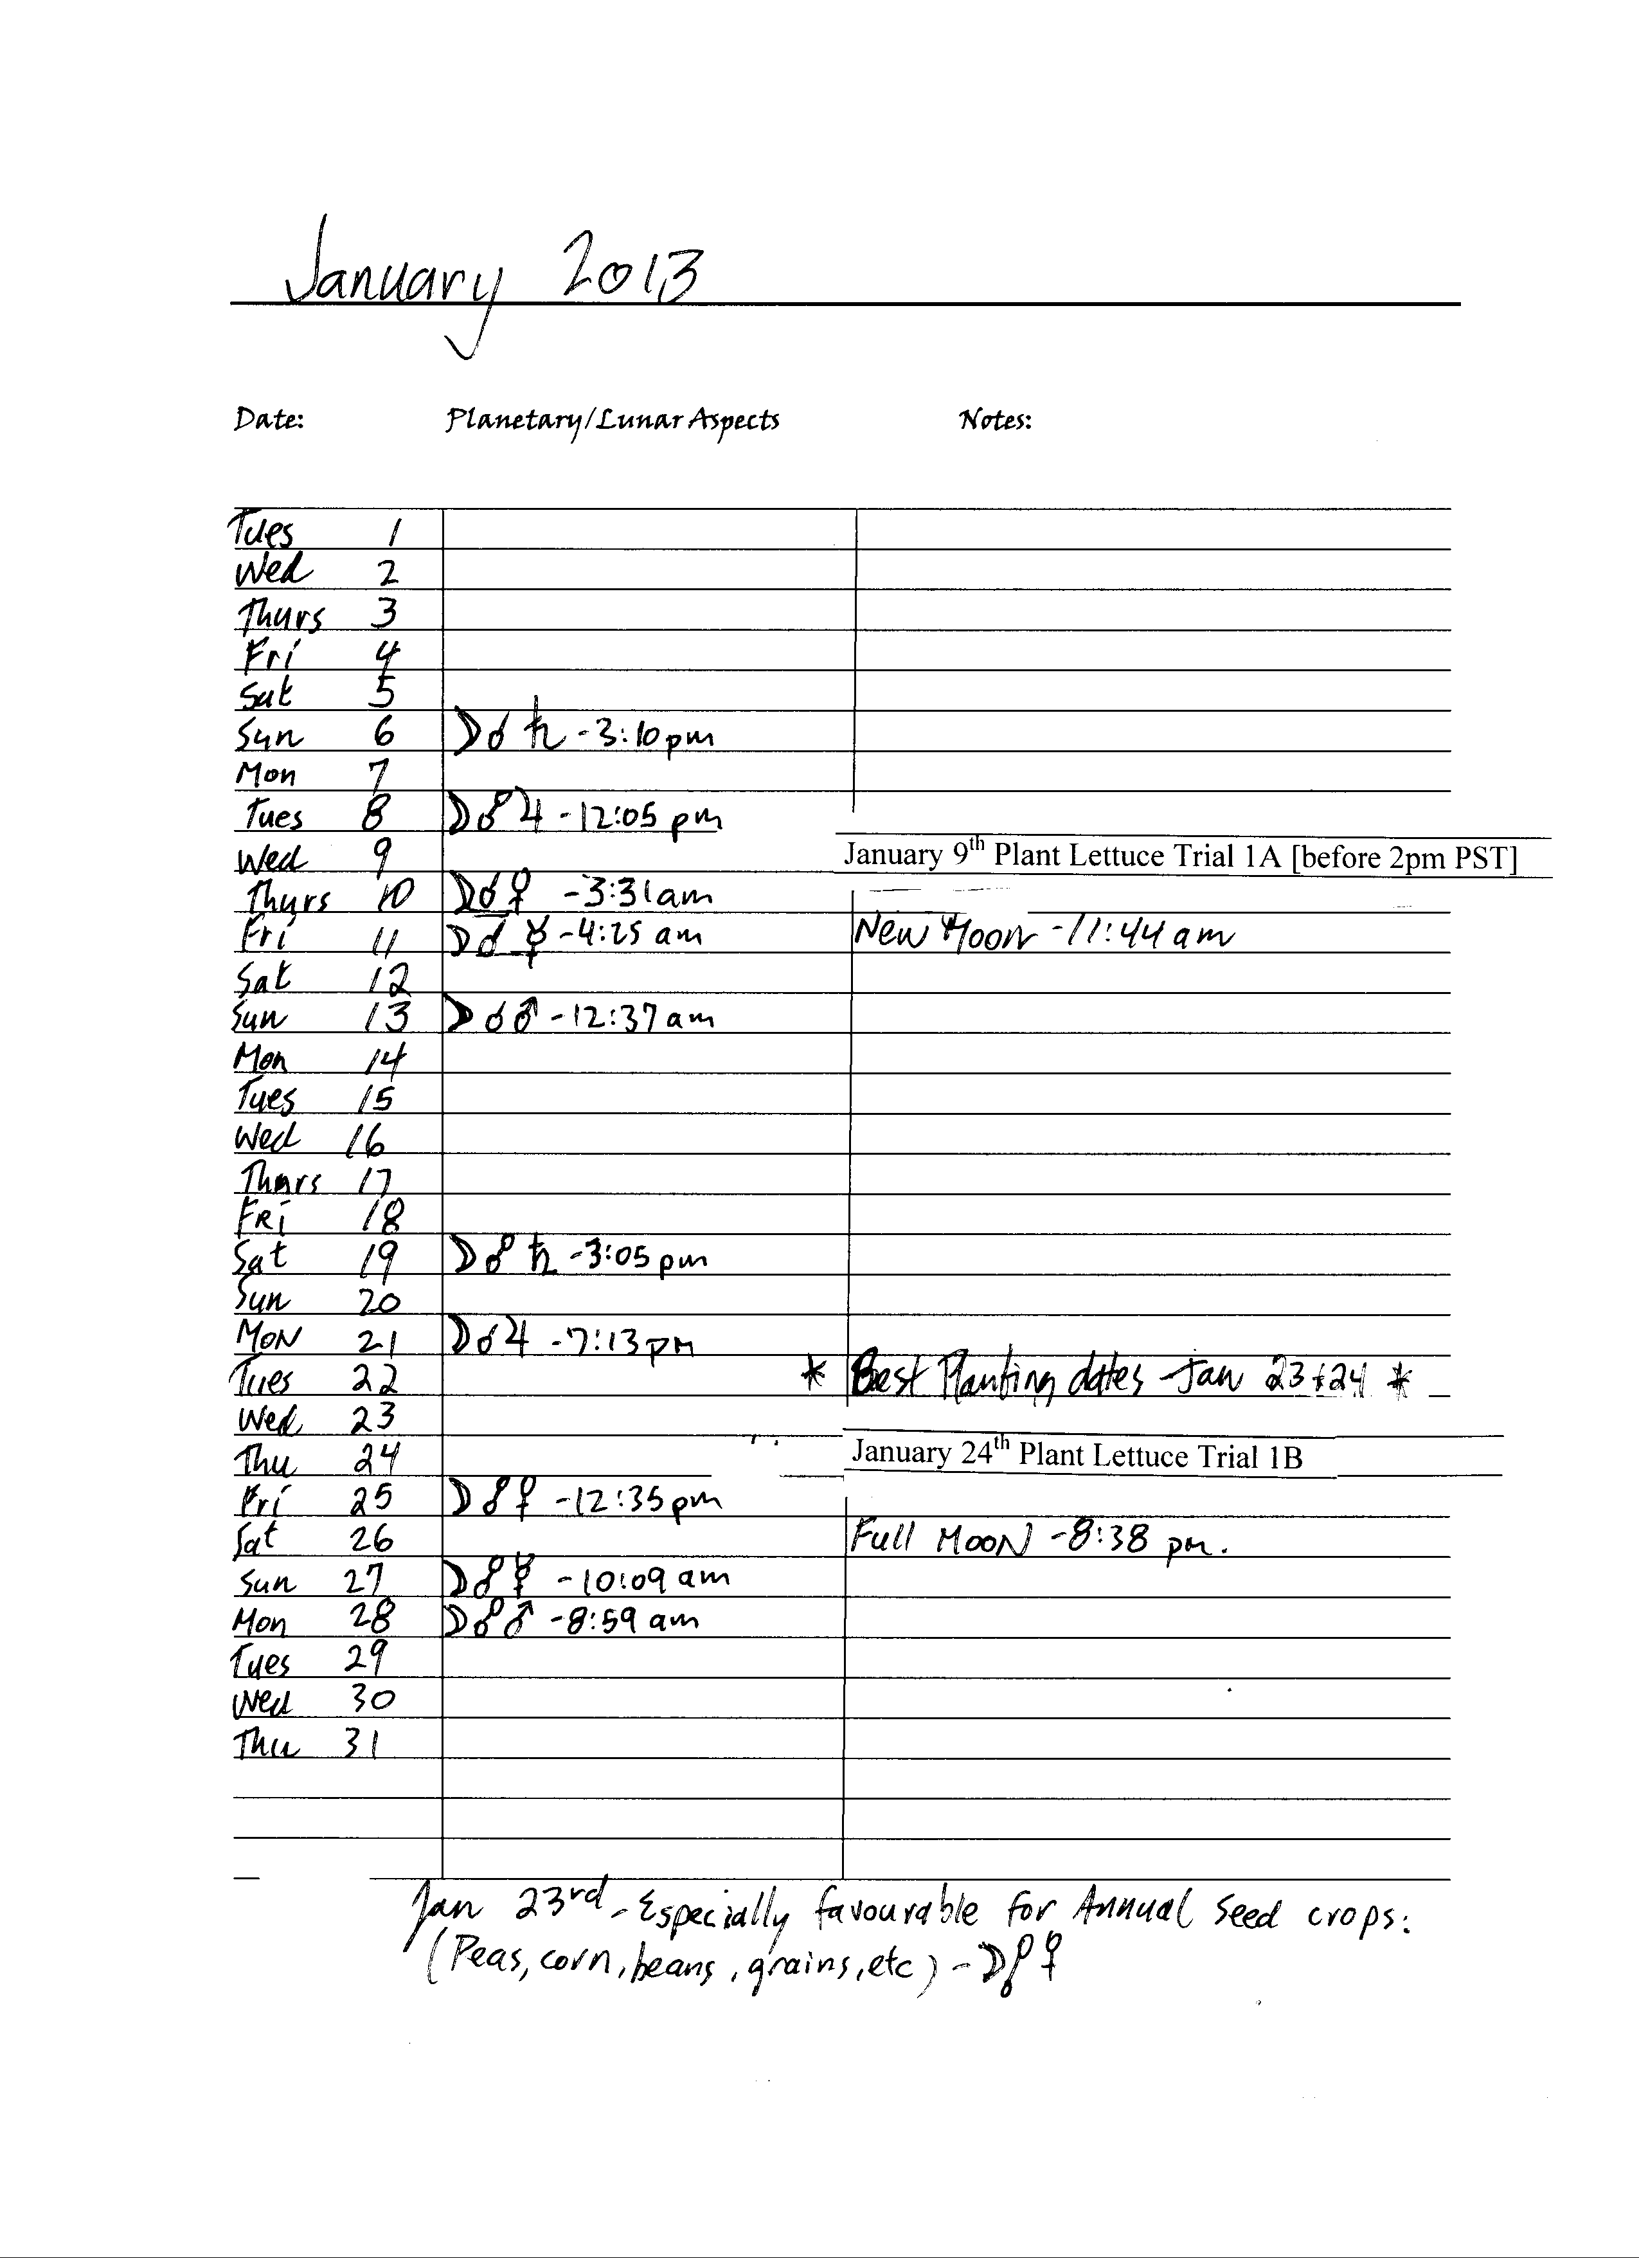 **Planting Trial #1a(windowsill only)**

**LETTUCE** - WCS LT449A Other- ______________________

Planting time: January 9th – Waning moon, leaf day (plant before 2 pm PST).

About West Coast Seeds LT449A: Lettuce can be harvested from the garden from late spring to the late fall, and sometimes (given a bit of protection) all winter. Lettuce grows best in cool weather in the spring and fall. Sow in April every 2-3 weeks for a continual harvest. Using a cloche, cold frame, or greenhouse over mid-late August plantings can extend the harvest period right into winter. Optimal soil temperature for germination: 10-22°C (50-72°F). Seeds should sprout in 7-15 days, depending on conditions. **Seeds don't sprout easily when the soil temperature is over 22°C (72°F) in summer.** Get around this by sprouting them indoors in a cool area, or pre-sprout by sprinkling seeds on a damp paper towel and placing it in a plastic bag in the fridge for a few days. In hot weather lettuce goes to seed rapidly, so have new plantings ready to go.

**Season:** Cool season  
**Exposure:** Full sun to partial shade  
**Zone:** 4-12

|  |  |  |  |  |
| --- | --- | --- | --- | --- |
| Seed | Germination time (days) | Plant height – roots Feb 8th (30 days) | Plant height + roots Feb 8th (30 days) | Total weight (whole plant) Feb 8th (30 days) |
| 1 |  |  |  |  |
| 2 |  |  |  |  |
| 3 |  |  |  |  |
| 4 |  |  |  |  |
| 5 |  |  |  |  |
| 6 |  |  |  |  |
| 7 |  |  |  |  |
| 8 |  |  |  |  |
| 9 |  |  |  |  |
| 10 |  |  |  |  |
| 11 |  |  |  |  |
| 12 |  |  |  |  |

Total Germination = /12

This form can be filled out on your computer and e-mailed directly to: [jbbach1@yahoo.ca](mailto:jbbach1@yahoo.ca)

Notes: Windowsill trial only-

|  |
| --- |
|  |
|  |
|  |
|  |
|  |
|  |
|  |
|  |

**Planting Trial #1b(windowsill only)**

**LETTUCE** - WCS LT449A Other- ______________________

Planting time: January 24th – Waxing moon, flower day

About West Coast Seeds LT449A: Lettuce can be harvested from the garden from late spring to the late fall, and sometimes (given a bit of protection) all winter. Lettuce grows best in cool weather in the spring and fall. Sow in April every 2-3 weeks for a continual harvest. Using a cloche, cold frame, or greenhouse over mid-late August plantings can extend the harvest period right into winter. Optimal soil temperature for germination: 10-22°C (50-72°F). Seeds should sprout in 7-15 days, depending on conditions. **Seeds don't sprout easily when the soil temperature is over 22°C (72°F) in summer.** Get around this by sprouting them indoors in a cool area, or pre-sprout by sprinkling seeds on a damp paper towel and placing it in a plastic bag in the fridge for a few days. In hot weather lettuce goes to seed rapidly, so have new plantings ready to go.

**Season:** Cool season  
**Exposure:** Full sun to partial shade  
**Zone:** 4-12

|  |  |  |  |  |
| --- | --- | --- | --- | --- |
| seed | Germination time (days) | Plant height – roots Feb 23rd (30 days) | Plant height + roots Feb 23rd (30 days) | Total weight (whole plant) Feb 23rd (30 days) |
| 1 |  |  |  |  |
| 2 |  |  |  |  |
| 3 |  |  |  |  |
| 4 |  |  |  |  |
| 5 |  |  |  |  |
| 6 |  |  |  |  |
| 7 |  |  |  |  |
| 8 |  |  |  |  |
| 9 |  |  |  |  |
| 10 |  |  |  |  |
| 11 |  |  |  |  |
| 12 |  |  |  |  |

Total Germination = /12

This form can be filled out on your computer and e-mailed directly to: [jbbach1@yahoo.ca](mailto:jbbach1@yahoo.ca)

Notes: Windowsill trial only

|  |
| --- |
|  |
|  |
|  |
|  |
|  |
|  |
|  |
|  |
|  |

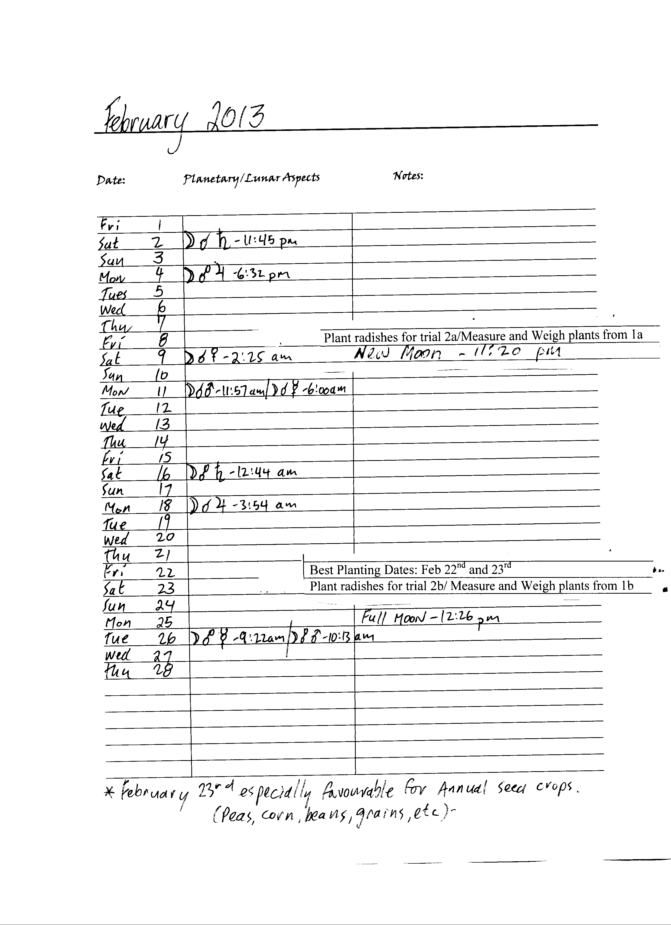

**Planting Trial #2a (windowsill only)**

**RADISHES** - RD684B Other- ______________________

Planting time: February 8th – Waning moon, root day (plant before 4 pm PST).

About West Coast Seeds RD684B: Time your radish plantings a week apart for a longer harvest period. The secret to growing a great radish is to plant when the weather is cool, to not plant too close together and to harvest promptly before the roots get woody and bitter. Every part of the radish is edible. If you leave some of your radishes to go to seed you'll find the pods before seed set are tender and juicy with a wonderfully sharp flavour that is excellent in stir-fries and soups. If you harvest the seeds before they dry they have a taste and the fresh seeds lightly sautéed with garlic and thyme on a bed of radish leaves. A gourmet delight! Radishes can be grown all season but they're easiest when sown March/April and again August through October. Optimal soil temperature: 18-24°C (65-75°F). Seeds should sprout in 5-7 days.

**Season:** Cool season  
**Exposure:** Full sun  
**Zone:** All

|  |  |  |  |  |
| --- | --- | --- | --- | --- |
| Seed | Germination time (days) | Plant height – roots March 10th (30 days) | Plant height + roots March 10th (30 days) | Total weight (whole plant) March 10th (30 days) |
| 1 |  |  |  |  |
| 2 |  |  |  |  |
| 3 |  |  |  |  |
| 4 |  |  |  |  |
| 5 |  |  |  |  |
| 6 |  |  |  |  |
| 7 |  |  |  |  |
| 8 |  |  |  |  |
| 9 |  |  |  |  |
| 10 |  |  |  |  |
| 11 |  |  |  |  |
| 12 |  |  |  |  |

Total Germination = /12

This form can be filled out on your computer and e-mailed directly to: [jbbach1@yahoo.ca](mailto:jbbach1@yahoo.ca)

Notes: Windowsill trial only

|  |
| --- |
|  |
|  |
|  |
|  |
|  |
|  |
|  |
|  |

**Planting Trial #2b (windowsill only)**

**RADISHES** - RD684B Other- ______________________

Planting time: February 23rd – Waxing moon, leaf day.

About West Coast Seeds RD684B: Time your radish plantings a week apart for a longer harvest period. The secret to growing a great radish is to plant when the weather is cool, to not plant too close together and to harvest promptly before the roots get woody and bitter. Every part of the radish is edible. If you leave some of your radishes to go to seed you'll find the pods before seed set are tender and juicy with a wonderfully sharp flavour that is excellent in stir-fries and soups. If you harvest the seeds before they dry they have a taste and the fresh seeds lightly sautéed with garlic and thyme on a bed of radish leaves. A gourmet delight! Radishes can be grown all season but they're easiest when sown March/April and again August through October. Optimal soil temperature: 18-24°C (65-75°F). Seeds should sprout in 5-7 days.

**Season:** Cool season  
**Exposure:** Full sun  
**Zone:** All

|  |  |  |  |  |
| --- | --- | --- | --- | --- |
| Seed | Germination time (days) | Plant height – roots March 25th (30 days) | Plant height + roots March 25th (30 days) | Total weight (whole plant) March 25th (30 days) |
| 1 |  |  |  |  |
| 2 |  |  |  |  |
| 3 |  |  |  |  |
| 4 |  |  |  |  |
| 5 |  |  |  |  |
| 6 |  |  |  |  |
| 7 |  |  |  |  |
| 8 |  |  |  |  |
| 9 |  |  |  |  |
| 10 |  |  |  |  |
| 11 |  |  |  |  |
| 12 |  |  |  |  |

Total Germination = /12

This form can be filled out on your computer and e-mailed directly to: [jbbach1@yahoo.ca](mailto:jbbach1@yahoo.ca)

Notes: Windowsill trial only

|  |
| --- |
|  |
|  |
|  |
|  |
|  |
|  |
|  |
|  |

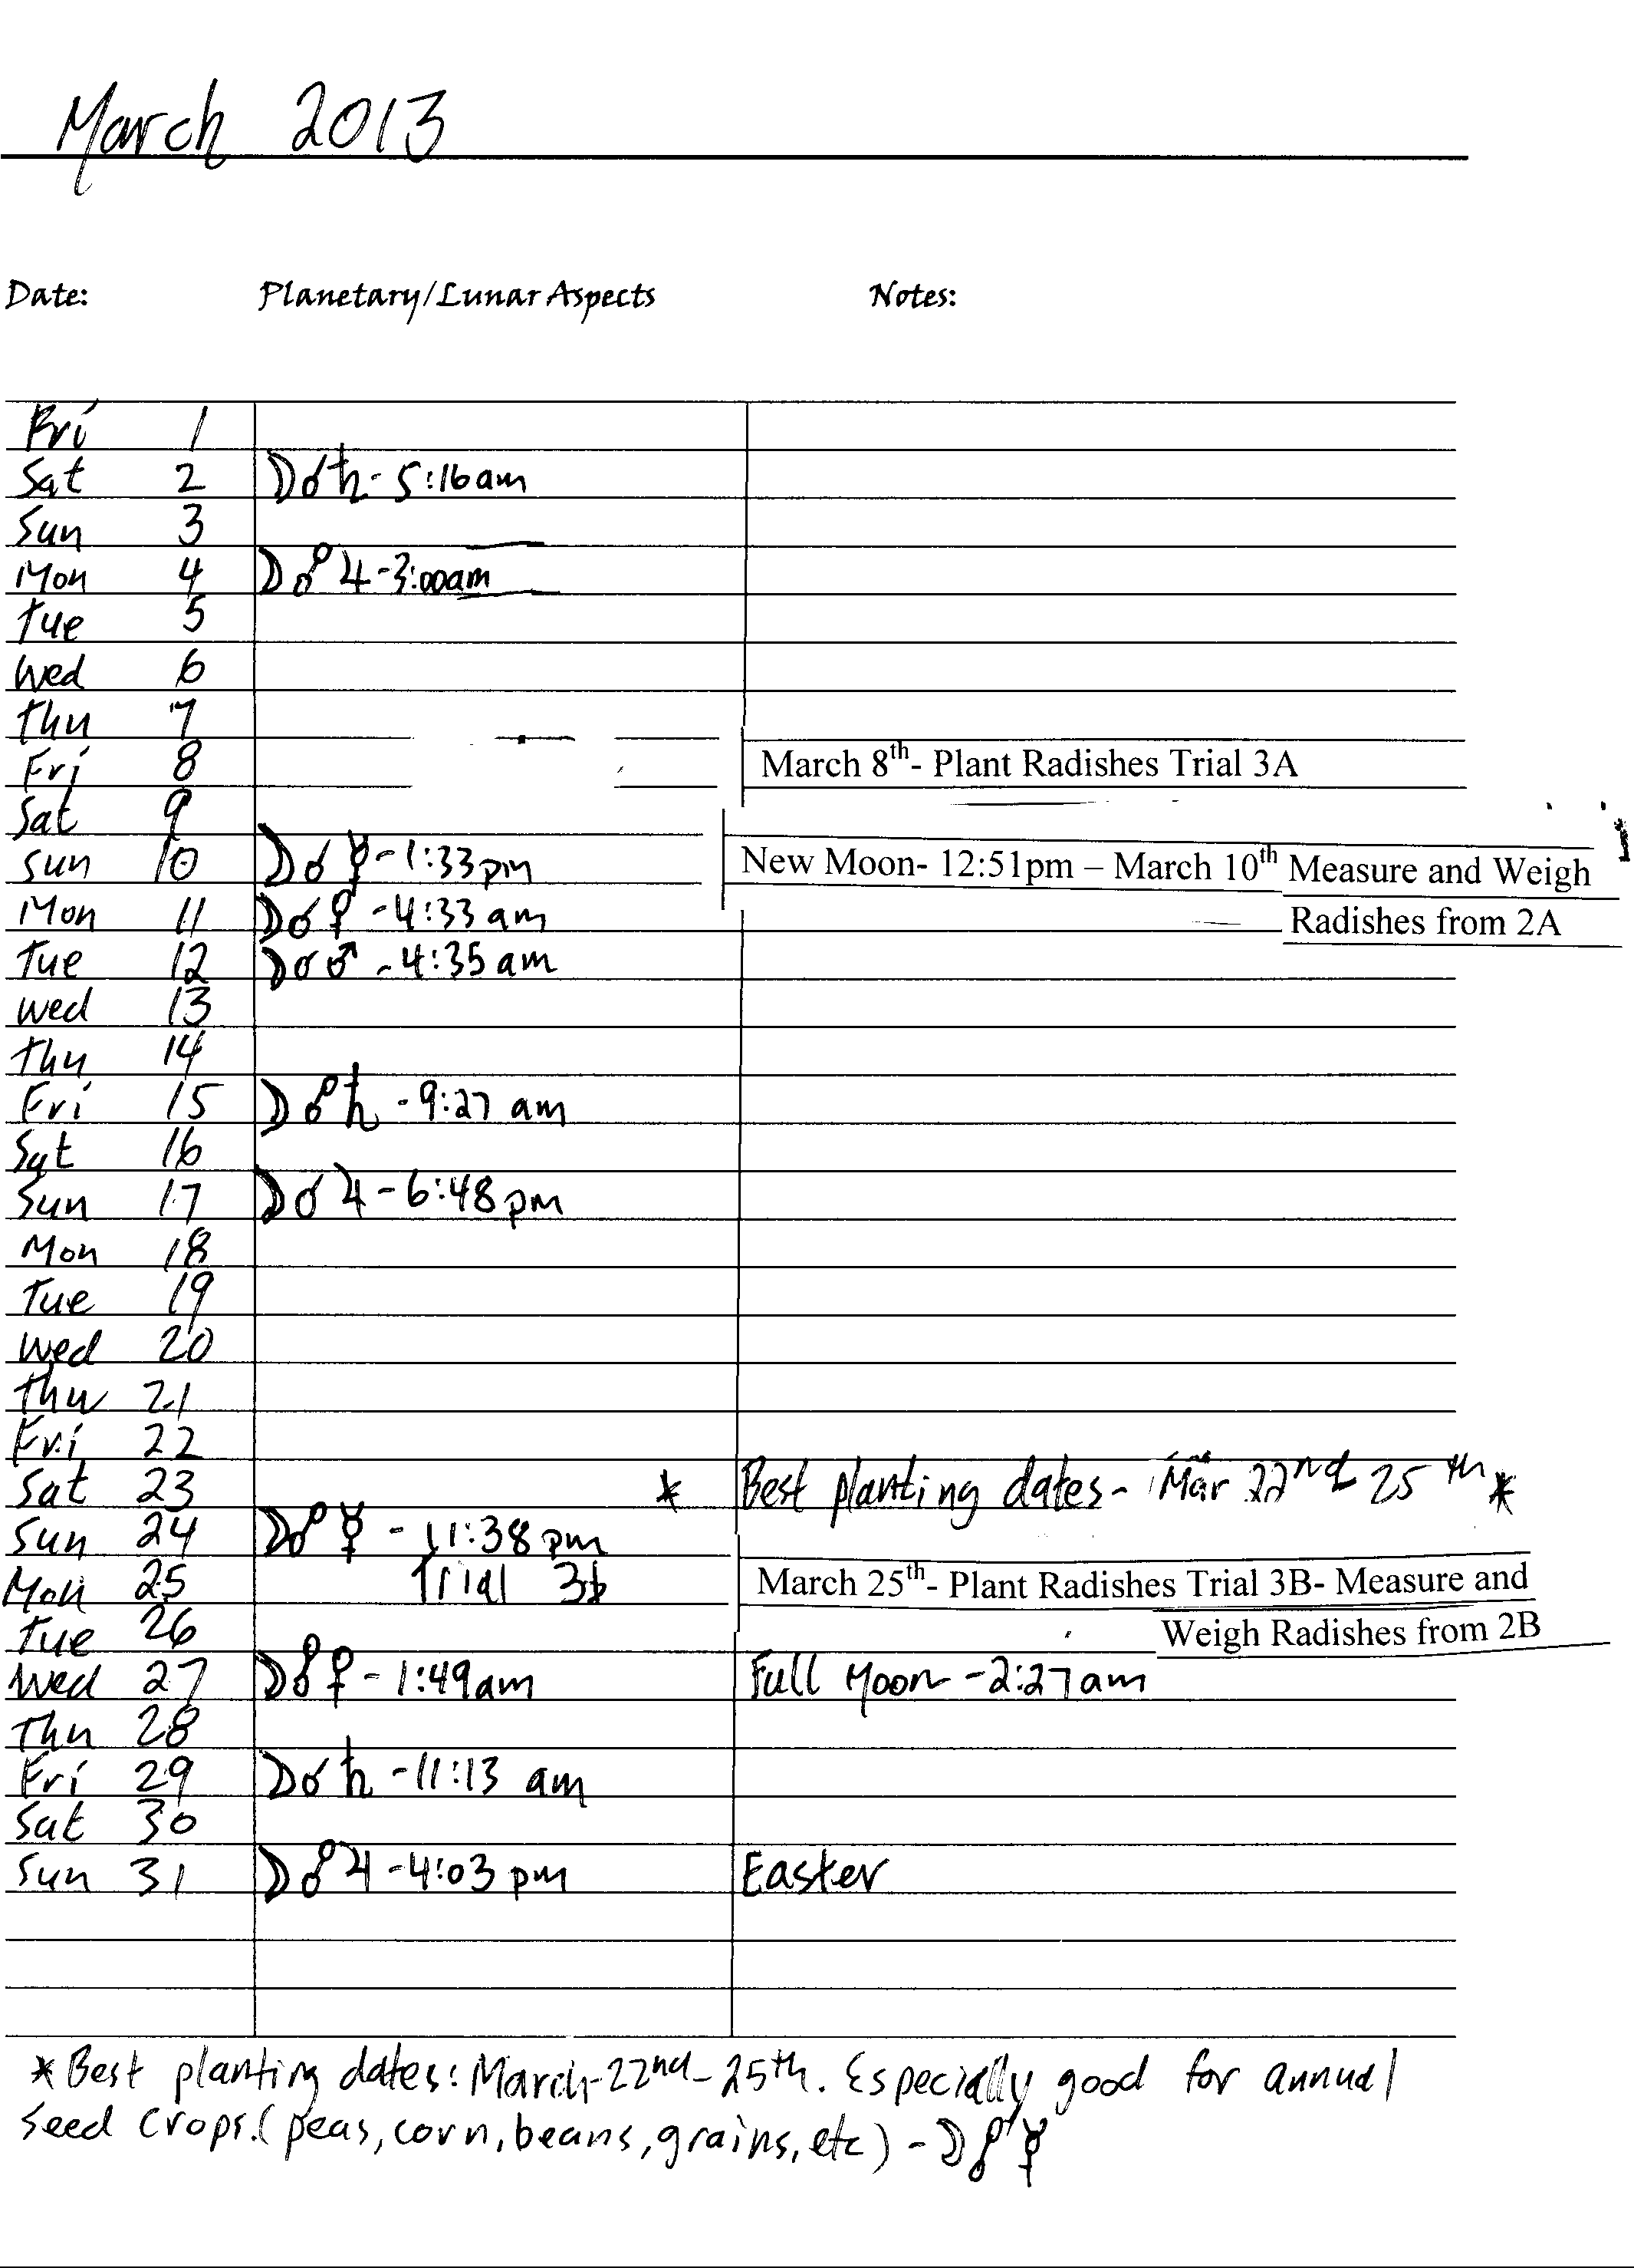

**Planting Trial #3a (windowsill only)**

**RADISHES** - RD684B Other- ______________________

Planting time: March 8th – Waning moon, root day.

About West Coast Seeds RD684B: Time your radish plantings a week apart for a longer harvest period. The secret to growing a great radish is to plant when the weather is cool, to not plant too close together and to harvest promptly before the roots get woody and bitter. Every part of the radish is edible. If you leave some of your radishes to go to seed you'll find the pods before seed set are tender and juicy with a wonderfully sharp flavour that is excellent in stir-fries and soups. If you harvest the seeds before they dry they have a taste and the fresh seeds lightly sautéed with garlic and thyme on a bed of radish leaves. A gourmet delight! Radishes can be grown all season but they're easiest when sown March/April and again August through October. Optimal soil temperature: 18-24°C (65-75°F). Seeds should sprout in 5-7 days.

**Season:** Cool season  
**Exposure:** Full sun  
**Zone:** All

|  |  |  |  |  |
| --- | --- | --- | --- | --- |
| Seed | Germination time (days) | Plant height – roots April 7th (30 days) | Plant height + roots April 7th (30 days) | Total weight (whole plant) April 7th (30 days) |
| 1 |  |  |  |  |
| 2 |  |  |  |  |
| 3 |  |  |  |  |
| 4 |  |  |  |  |
| 5 |  |  |  |  |
| 6 |  |  |  |  |
| 7 |  |  |  |  |
| 8 |  |  |  |  |
| 9 |  |  |  |  |
| 10 |  |  |  |  |
| 11 |  |  |  |  |
| 12 |  |  |  |  |

Total Germination = /12

This form can be filled out on your computer and e-mailed directly to: [jbbach1@yahoo.ca](mailto:jbbach1@yahoo.ca)

Notes: windowsill trial only

|  |
| --- |
|  |
|  |
|  |
|  |
|  |
|  |
|  |
|  |

**Planting Trial #3b (windowsill only)**

**RADISHES** - RD684B Other- ______________________

Planting time: March 25th – Waxing moon, fruit day.

About West Coast Seeds RD684B: Time your radish plantings a week apart for a longer harvest period. The secret to growing a great radish is to plant when the weather is cool, to not plant too close together and to harvest promptly before the roots get woody and bitter. Every part of the radish is edible. If you leave some of your radishes to go to seed you'll find the pods before seed set are tender and juicy with a wonderfully sharp flavour that is excellent in stir-fries and soups. If you harvest the seeds before they dry they have a taste and the fresh seeds lightly sautéed with garlic and thyme on a bed of radish leaves. A gourmet delight! Radishes can be grown all season but they're easiest when sown March/April and again August through October. Optimal soil temperature: 18-24°C (65-75°F). Seeds should sprout in 5-7 days.

**Season:** Cool season  
**Exposure:** Full sun  
**Zone:** All

|  |  |  |  |  |
| --- | --- | --- | --- | --- |
| Seed | Germination time (days) | Plant height – roots April 24th (30 days) | Plant height + roots April 24th (30 days) | Total weight (whole plant) April 24th (30 days) |
| 1 |  |  |  |  |
| 2 |  |  |  |  |
| 3 |  |  |  |  |
| 4 |  |  |  |  |
| 5 |  |  |  |  |
| 6 |  |  |  |  |
| 7 |  |  |  |  |
| 8 |  |  |  |  |
| 9 |  |  |  |  |
| 10 |  |  |  |  |
| 11 |  |  |  |  |
| 12 |  |  |  |  |

Total Germination = /12

This form can be filled out on your computer and e-mailed directly to: [jbbach1@yahoo.ca](mailto:jbbach1@yahoo.ca)

Notes: windowsill trial only

|  |
| --- |
|  |
|  |
|  |
|  |
|  |
|  |
|  |
|  |

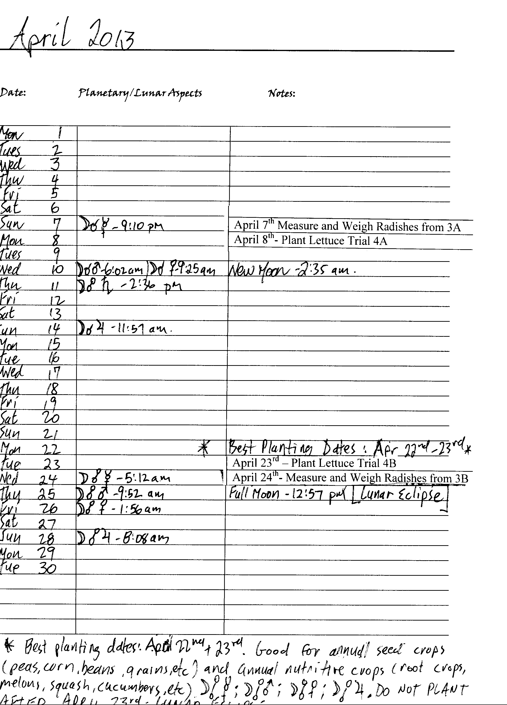

**Planting Trial #4a (plant- out full maturity trial)**

**LETTUCE** - LT449A Other- ______________________

Planting time: April 8th – Waning moon, leaf day

About West Coast Seeds LT449A: Lettuce grows best in cool weather in the spring and fall. Sow in April every 2-3 weeks for a continual harvest. Using a cloche, cold frame, or greenhouse over mid-late August plantings can extend the harvest period right into winter. Optimal soil temperature for germination: 10-22°C (50-72°F). Seeds should sprout in 7-15 days, depending on conditions. **Seeds don't sprout easily when the soil temperature is over 22°C (72°F) in summer.** Get around this by sprouting them indoors in a cool area, or pre-sprout by sprinkling seeds on a damp paper towel and placing it in a plastic bag in the fridge for a few days. In hot weather lettuce goes to seed rapidly, so have new plantings ready to go. Matures in 55 days.

**Season:** Cool season  
**Exposure:** Full sun to partial shade  
**Zone:** 4-12

|  |  |  |  |
| --- | --- | --- | --- |
| Seed | Germination time (days) | Plant height - May 8th (30 days) | Total weight (whole plant) – June 2nd |
| 1 |  |  |  |
| 2 |  |  |  |
| 3 |  |  |  |
| 4 |  |  |  |
| 5 |  |  |  |
| 6 |  |  |  |
| 7 |  |  |  |
| 8 |  |  |  |
| 9 |  |  |  |
| 10 |  |  |  |
| 11 |  |  |  |
| 12 |  |  |  |

Total Germination = /12

This form can be filled out on your computer and e-mailed directly to: [jbbach1@yahoo.ca](mailto:jbbach1@yahoo.ca)

Notes: Plant-out Lettuce on May 8th

|  |
| --- |
|  |
|  |
|  |
|  |
|  |
|  |
|  |
|  |

**Planting Trial #4b (plant- out full maturity trial)**

**LETTUCE** - LT449A Other- _____________________

Planting time: April 23rd – Waxing moon, leaf day

About West Coast Seeds LT449A: Lettuce grows best in cool weather in the spring and fall. Sow in April every 2-3 weeks for a continual harvest. Using a cloche, cold frame, or greenhouse over mid-late August plantings can extend the harvest period right into winter. Optimal soil temperature for germination: 10-22°C (50-72°F). Seeds should sprout in 7-15 days, depending on conditions. **Seeds don't sprout easily when the soil temperature is over 22°C (72°F) in summer.** Get around this by sprouting them indoors in a cool area, or pre-sprout by sprinkling seeds on a damp paper towel and placing it in a plastic bag in the fridge for a few days. In hot weather lettuce goes to seed rapidly, so have new plantings ready to go. Matures in 55 days.

**Season:** Cool season  
**Exposure:** Full sun to partial shade  
**Zone:** 4-12

|  |  |  |  |
| --- | --- | --- | --- |
| Seed | Germination time (days) | Plant height - May 23rd (30 days) | Total weight (whole plant) – June 17th |
| 1 |  |  |  |
| 2 |  |  |  |
| 3 |  |  |  |
| 4 |  |  |  |
| 5 |  |  |  |
| 6 |  |  |  |
| 7 |  |  |  |
| 8 |  |  |  |
| 9 |  |  |  |
| 10 |  |  |  |
| 11 |  |  |  |
| 12 |  |  |  |

Total Germination = /12

This form can be filled out on your computer and e-mailed directly to: [jbbach1@yahoo.ca](mailto:jbbach1@yahoo.ca)

Notes: Plant out lettuce on May 23rd

|  |
| --- |
|  |
|  |
|  |
|  |
|  |
|  |
|  |
|  |

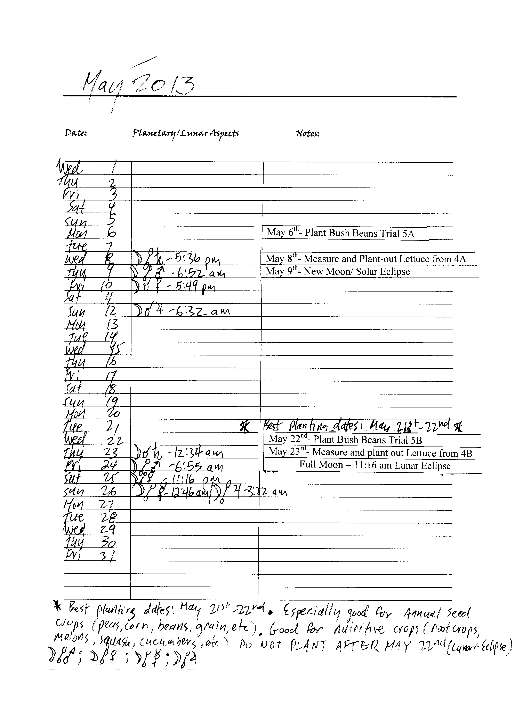

**Planting Trial #5a (plant- out full maturity trial)**

**BUSH BEANS** - BN119C Other- _____________________

Planting time: May 6th (after 3 pm PST) – Waning moon, fruit day

About West Coast Seeds BN119C: Direct sow from mid-May to the beginning of July. Try to plant during a warm, dry spell. Soil must be warm - if it is not warm enough, seeds will rot, especially our untreated seeds. Optimal soil temperature: 21-32°C (70-90°F). Sow seeds 2-5cm (1-2") deep, 5-8cm (2-3") apart, in rows 45-60cm (18-24") apart. Thin to at least 15cm (6") apart in each row. Using bean or combination inoculants on seeds helps growth. If the weather is too wet, beans can also be started in pots indoors and set out carefully a few weeks later. For a continuous harvest, plant at 3 week intervals. Seeds will sprout in 8-16 days, depending on conditions. Matures in 56 days.

**Season:** Warm season  
**Exposure:** Full-sun  
**Zone:** 3 and warmer

|  |  |  |  |  |
| --- | --- | --- | --- | --- |
| Seed | Germination time (days) | Plant height - June 5th (30 days) | Number of pods harvested – July 1st | Total weight of pods harvested- July 1st |
| 1 |  |  |  |  |
| 2 |  |  |  |  |
| 3 |  |  |  |  |
| 4 |  |  |  |  |
| 5 |  |  |  |  |
| 6 |  |  |  |  |
| 7 |  |  |  |  |
| 8 |  |  |  |  |
| 9 |  |  |  |  |
| 10 |  |  |  |  |
| 11 |  |  |  |  |
| 12 |  |  |  |  |

Total Germination = /12

This form can be filled out on your computer and e-mailed directly to: [jbbach1@yahoo.ca](mailto:jbbach1@yahoo.ca)

Notes: Plant out beans on June 5th

|  |
| --- |
|  |
|  |
|  |
|  |
|  |
|  |
|  |
|  |

**Planting Trial #5b (plant- out full maturity trial)**

**BUSH BEANS** - BN119C Other- _____________________

Planting time: May 22nd – Waxing moon, root day

About West Coast Seeds BN119C**:** Direct sow from mid-May to the beginning of July. Try to plant during a warm, dry spell. Soil must be warm - if it is not warm enough, seeds will rot, especially our untreated seeds. Optimal soil temperature: 21-32°C (70-90°F). Sow seeds 2-5cm (1-2") deep, 5-8cm (2-3") apart, in rows 45-60cm (18-24") apart. Thin to at least 15cm (6") apart in each row. Using bean or combination inoculants on seeds helps growth. If the weather is too wet, beans can also be started in pots indoors and set out carefully a few weeks later. For a continuous harvest, plant at 3 week intervals. Seeds will sprout in 8-16 days, depending on conditions. Matures in 56 days.

**Season:** Warm season  
**Exposure:** Full-sun  
**Zone:** 3 and warmer

|  |  |  |  |  |
| --- | --- | --- | --- | --- |
| Seed | Germination time (days) | Plant height - June 21st (30 days) | Number of pods harvested – July 17th | Total weight of pods harvested – July 17th |
| 1 |  |  |  |  |
| 2 |  |  |  |  |
| 3 |  |  |  |  |
| 4 |  |  |  |  |
| 5 |  |  |  |  |
| 6 |  |  |  |  |
| 7 |  |  |  |  |
| 8 |  |  |  |  |
| 9 |  |  |  |  |
| 10 |  |  |  |  |
| 11 |  |  |  |  |
| 12 |  |  |  |  |

Total Germination = /12

This form can be filled out on your computer and e-mailed directly to: [jbbach1@yahoo.ca](mailto:jbbach1@yahoo.ca)

Notes: Plant out beans on June 21st

|  |
| --- |
|  |
|  |
|  |
|  |
|  |
|  |
|  |
|  |

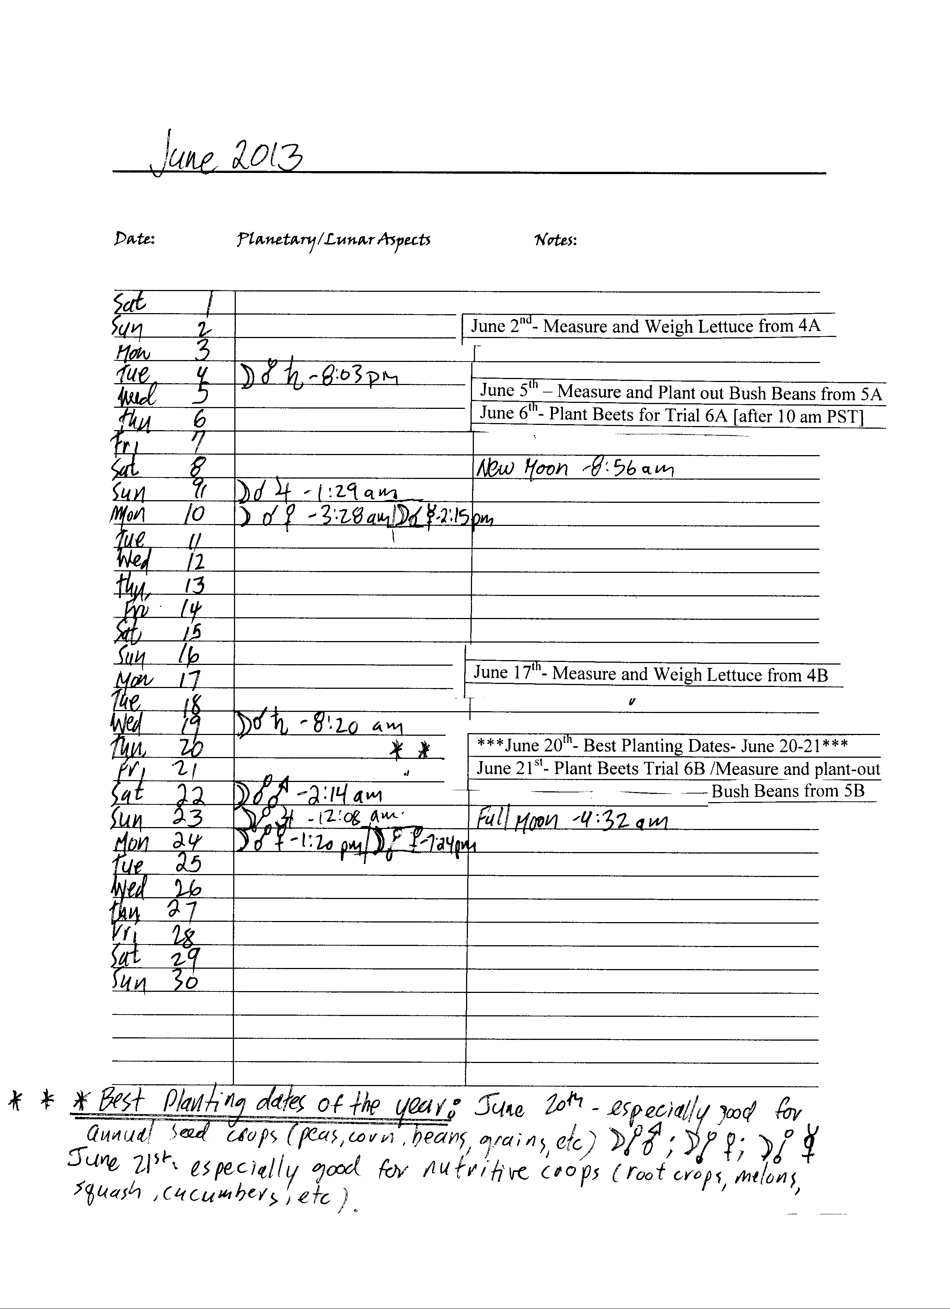

**Planting Trial 6a (plant- out full maturity trial)**

**BEETS**- BT165C Other- _____________________

Planting time: June 6th [after 10 am PST] – Waning moon, root day

About West Coast Seeds BT165C**:** Direct sow late April to mid-July. Beets will not produce roots if planted when the soil is too cold. Seeds will germinate in 5-12 days, depending on soil temperature**. Optimal soil temperature: 10-26°C (50-80°F).**

**Season:** Cool Season  
**Exposure:** Full-sun or partial-shade  
**Zone:** Hardy to Zone 5

|  |  |  |  |  |
| --- | --- | --- | --- | --- |
| Seed | Germination time (days) | Plant height - July 6th (30 days) | Total weight - whole plant Aug 5th - (60 days) | Total weight –Root only Aug 5th- (60 days) |
| 1 |  |  |  |  |
| 2 |  |  |  |  |
| 3 |  |  |  |  |
| 4 |  |  |  |  |
| 5 |  |  |  |  |
| 6 |  |  |  |  |
| 7 |  |  |  |  |
| 8 |  |  |  |  |
| 9 |  |  |  |  |
| 10 |  |  |  |  |
| 11 |  |  |  |  |
| 12 |  |  |  |  |

Total Germination = /12

This form can be filled out on your computer and e-mailed directly to: [jbbach1@yahoo.ca](mailto:jbbach1@yahoo.ca)

Notes: Plant out beets on July 6th

|  |
| --- |
|  |
|  |
|  |
|  |
|  |
|  |
|  |
|  |

**Planting Trial 6b (plant- out full maturity trial)**

**BEETS**- BT165C Other- _____________________

Planting time: June 21st – Waxing moon, flower/leaf day

About West Coast Seeds BT165C**:** Direct sow late April to mid-July. Beets will not produce roots if planted when the soil is too cold. Seeds will germinate in 5-12 days, depending on soil temperature**. Optimal soil temperature: 10-26°C (50-80°F).**

**Season:** Cool Season  
**Exposure:** Full-sun or partial-shade  
**Zone:** Hardy to Zone 5

|  |  |  |  |  |
| --- | --- | --- | --- | --- |
| Seed | Germination time (days) | Plant height - July 21st- (30 days) | Weight of whole plant – Aug 20th | Weight of root – Aug 20th |
| 1 |  |  |  |  |
| 2 |  |  |  |  |
| 3 |  |  |  |  |
| 4 |  |  |  |  |
| 5 |  |  |  |  |
| 6 |  |  |  |  |
| 7 |  |  |  |  |
| 8 |  |  |  |  |
| 9 |  |  |  |  |
| 10 |  |  |  |  |
| 11 |  |  |  |  |
| 12 |  |  |  |  |

Total Germination = /12

This form can be filled out on your computer and e-mailed directly to: [jbbach1@yahoo.ca](mailto:jbbach1@yahoo.ca)

Notes: Plant out beets on July 21st

|  |
| --- |
|  |
|  |
|  |
|  |
|  |
|  |
|  |
|  |

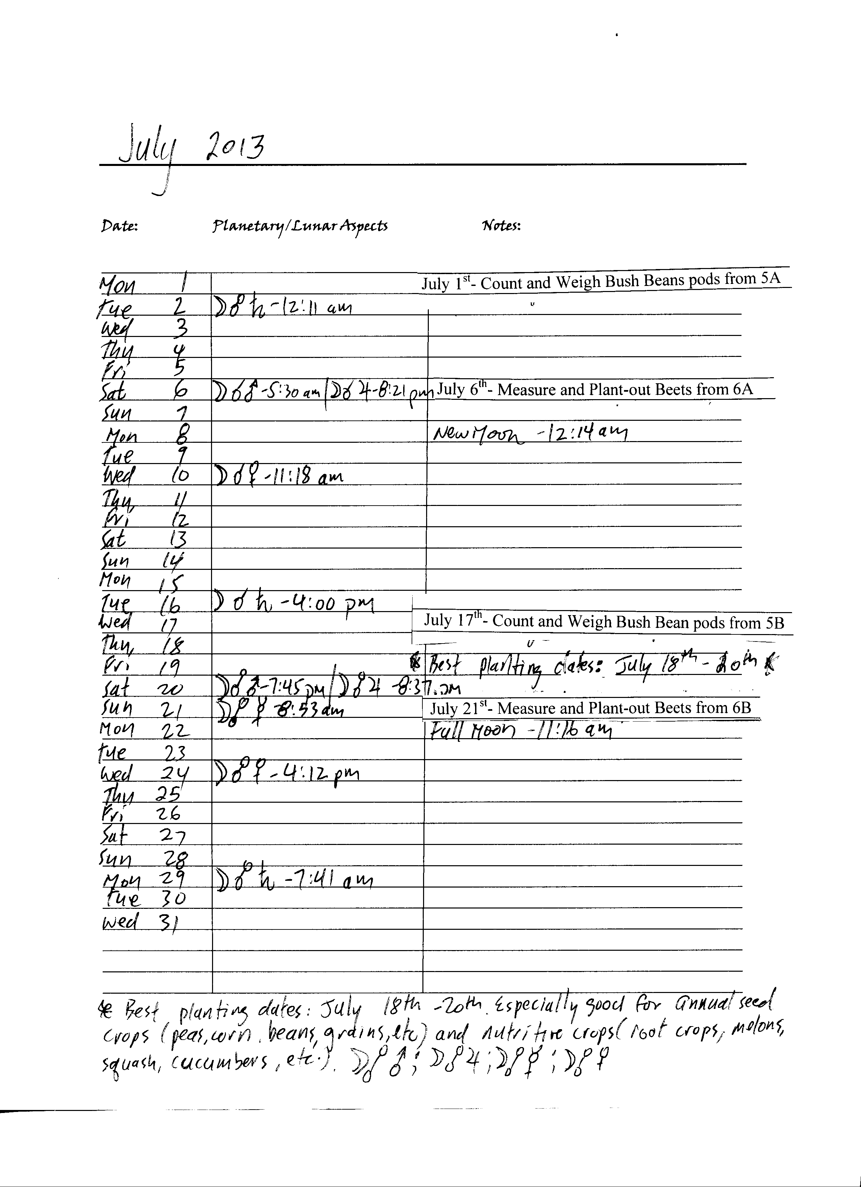

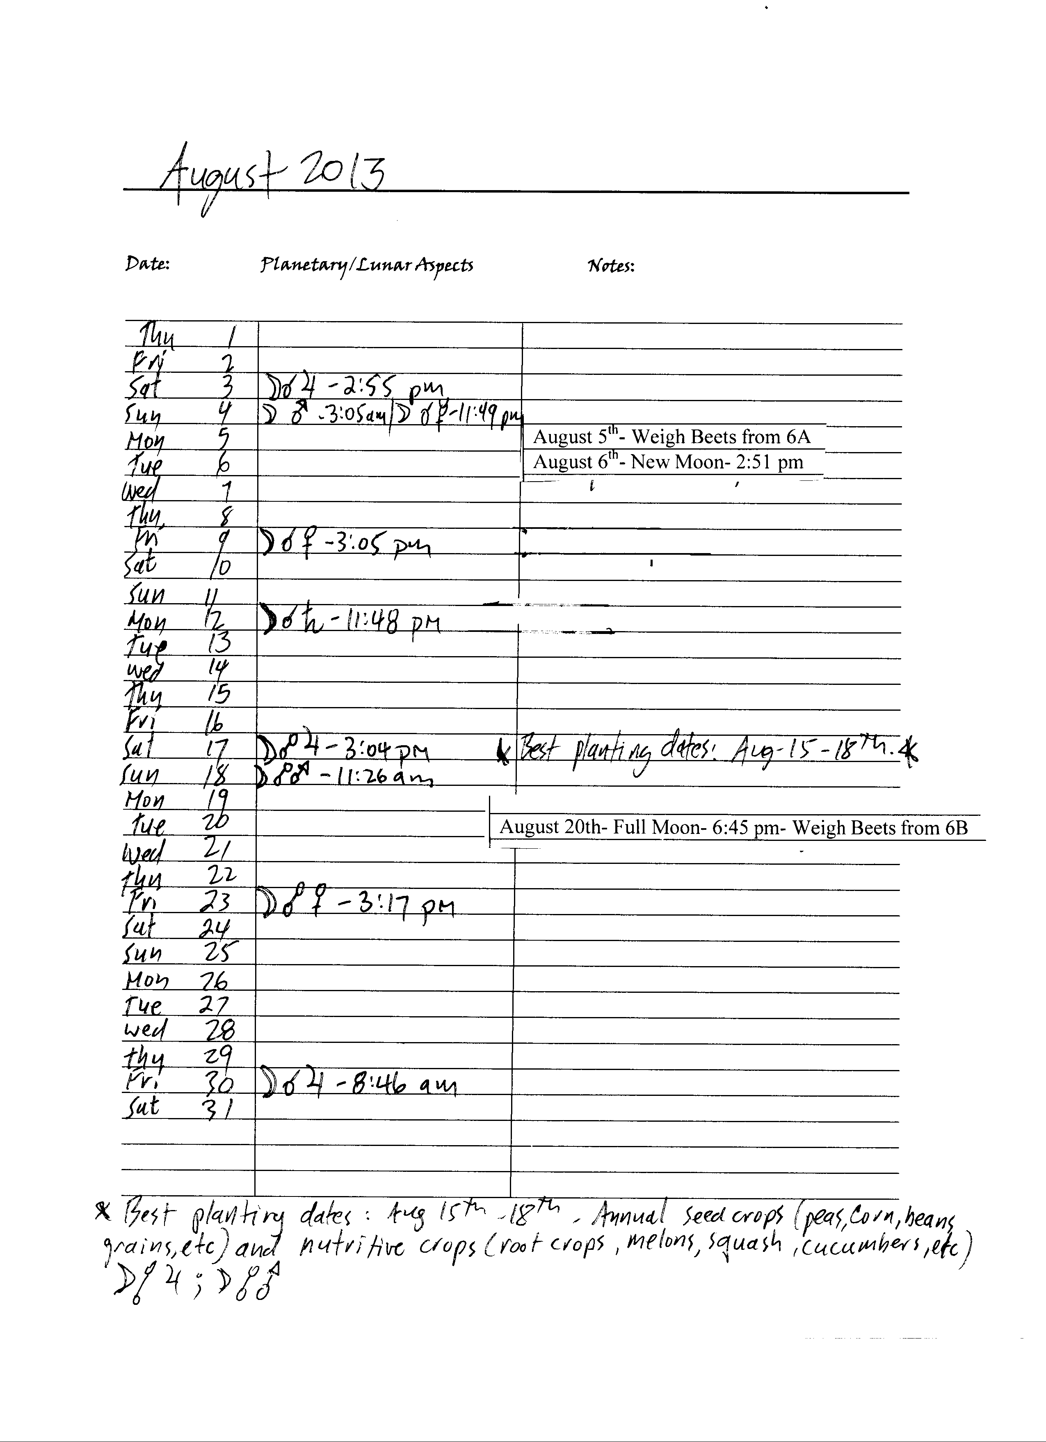

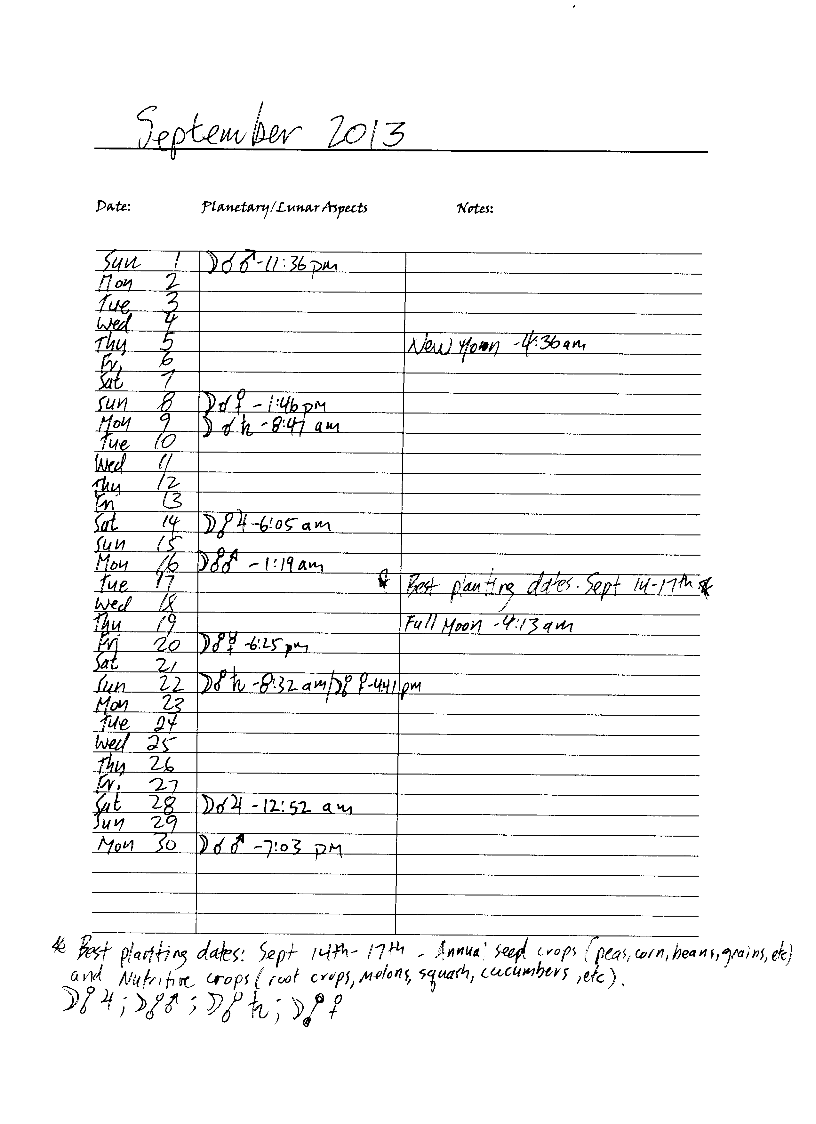

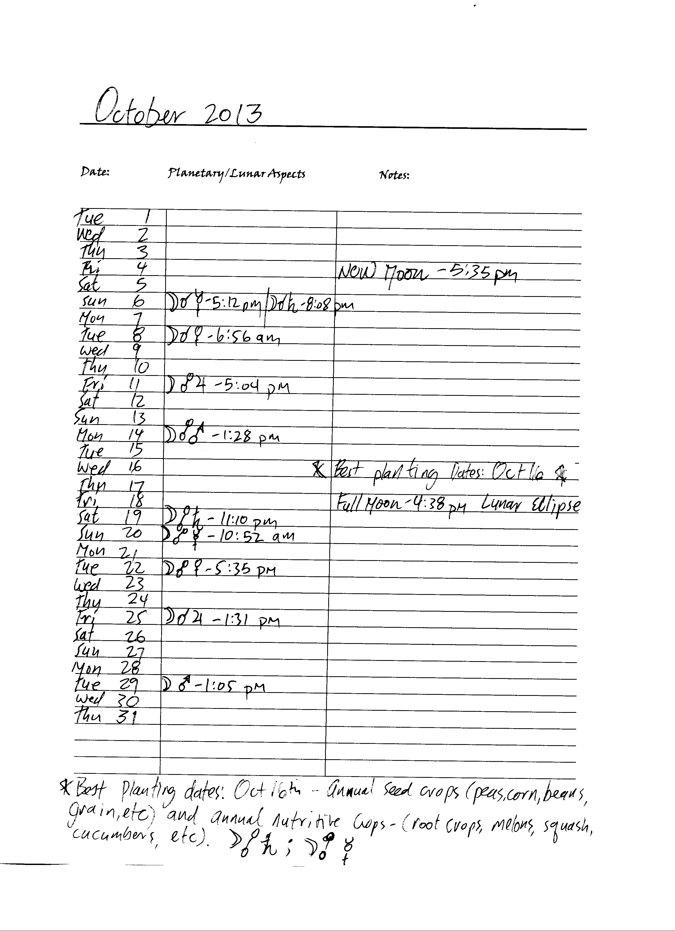

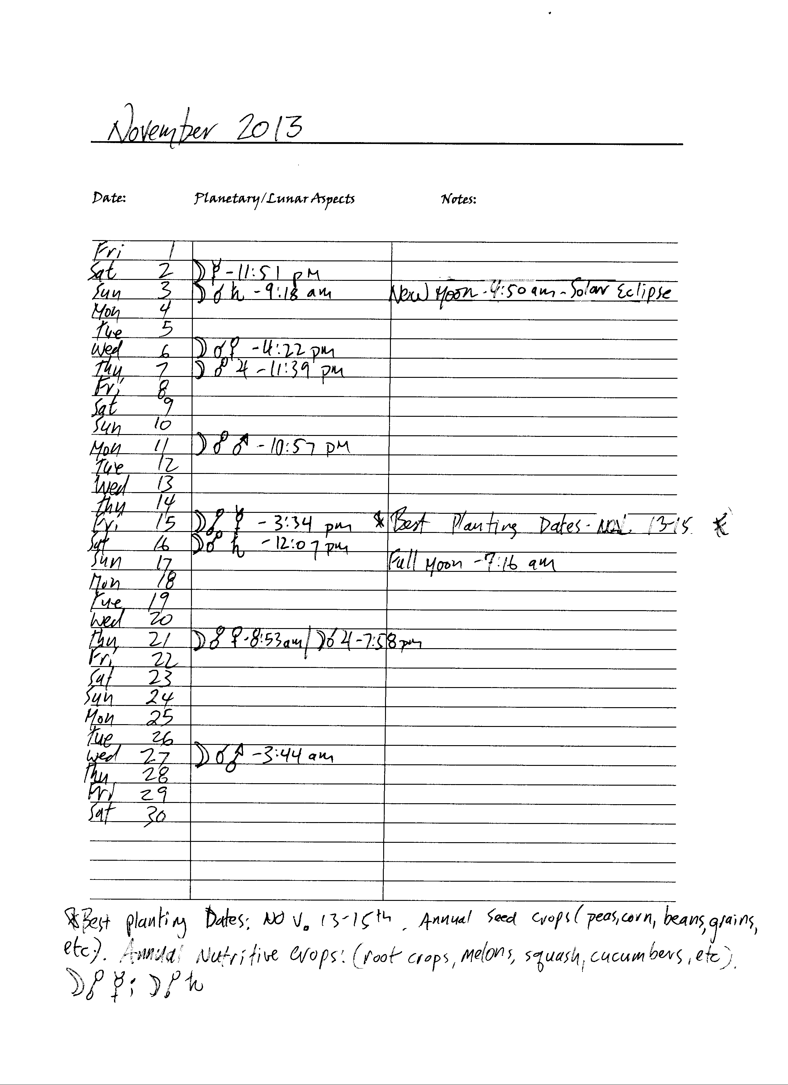

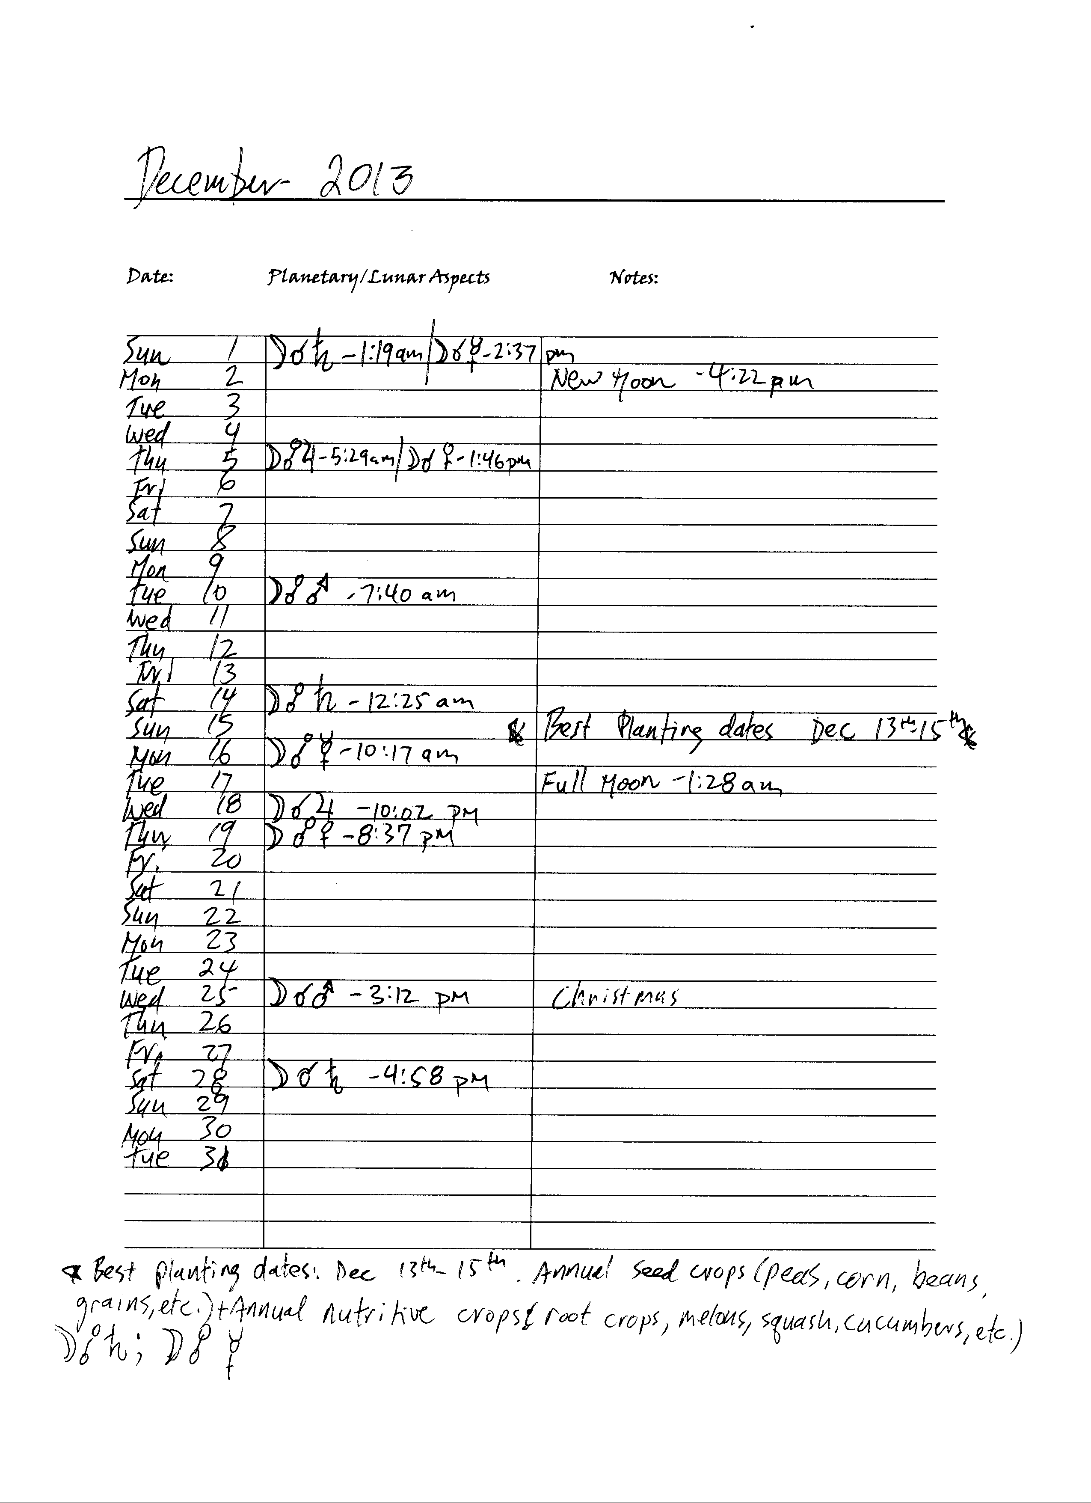

1. *The Agriculture Course* is available for free at <http://www.rsarchive.org>
2. Steiner, R. (2004). *Agricultural Course, The Birth of the Biodynamic Method.* Eight Lectures given in Koberwitz, Silesia, between 7 and 16 June 1924. Rudolf Steiner Press.
3. *Agriculture of Tomorrow* is available as a free download from <http://www.archive.org>
4. Kolisko, L. & Kolisko E. (1978). Agriculture of Tomorrow. Kolisko Archive Publications. Part 1 chapter 2, p.14. Retrieved from <http://www.archive.org>